Inferential statistics: Coming up with inferences or conclusions from a sample data about an unknown population parameter (eg: mean, variance, etc).

Hypothesis and Testing Mechanism:

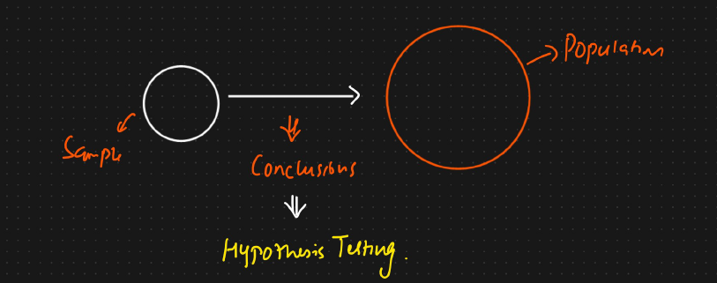

Hypothesis testing mechanism:  
1. Null hypothesis ($H_{0}$): The assumption we are beginning with

2. Alternate hypothesis ($H_{1}$): Opposite of null hypothesis.

3.Experiments: Perform statistical analysis

4. Accept the Null hypothesis or reject the Null hypothesis

Example: Colleges at District A states its average passed percentage of students are 85%. A new college opened in the district and it was found that a sample of 100 students have a pass percentage of 90%, with a standard deviation of 4%.

Does this college have a different pass percentage?

Null hypothesis ($H_{0}$) = $μ$ = 85%

Alternate hypothesis ($H_{1}$) = $μ$ $≠$ 85%